RCI Safety Precautions for COVID 19
The safety of our students is a top priority. Unfortunately, these are not normal times so we need to adjust to the new normal for the fall semester face-to-face classes. These guidelines may also change as we move forward.
- All universities are requiring masks for students and professors. You will be responsible to provide your own mask and wear it will attending RCI.
- Classroom seating will be set up for social distancing. Please do not move any seats as they have all been measured according to the guidelines.
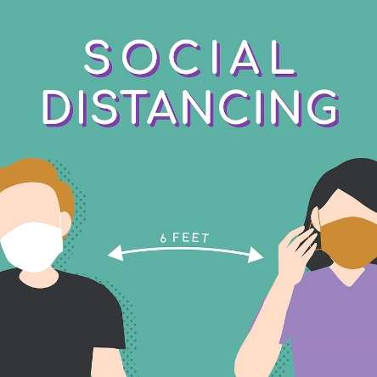

Please reach out if you have additional questions, rci@iu5.org.

