General Reading Resources

 | Elementary | The Story Place  http://www.storyplace.org | Star Fall  http://www.starfall.com
 | Secondary | ESL Site  http://www.isabelperez.com
ELL Student Resources | 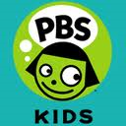  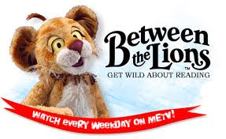  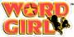  - Games-Power Words  - Videos  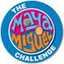 | Read Alouds:  Tumble Book Library  http://gvpl.ca/interests/kids-tweens/tumblebooks-more  - Children’s fairytales in Spanish  - The Story Place, The Golden Ball  http://www.storyplace.org/eel/activities/goldenball.asp
Parent/Family Resources | Colorin Colorado! Tip Sheets –available in English and Spanish  Grades 4-6: http://www.aft.org/pdfs/teachers/ell_46reading0608.pdf  Grades 4-12:  http://www.aft.org/pdfs/teachers/ell_whattodofirst0608.pdf  Vocabulary  http://www.aft.org/pdfs/teachers/ell_vocabulary0608.pdf  Grades 7-12:  http://www.aft.org/pdfs/teachers/ell_712reading0608.pdf
Teacher Resources | Florida Center for Reading Research (FCRR)  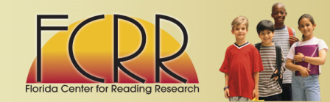  Student Center Activities  http://www.fcrr.org/curriculum/SCAindex.shtm | ELL Starter Kit – Colorin Colorado!  http://www.aft.org/pdfs/teachers/ccstarterkit0607.pdf  Booklists  http://www.colorincolorado.org/read/forkids  Webcasts with Experts  http://www.colorincolorado.org/webcasts/ | Reading Rockets  www.readingrockets.org  - help for struggling readers  - webcasts with authors and experts  - classroom practices
Web 2.0 Tools | Wall Wisher  www.wallwisher.com  online corkboard  - post comments | Blabberize  www.blabberize.com  - make a picture talk | Wordle  www.wordle.net  - create a word cloud, or collage of words | Universal Design for Learning  www.cast.org  Opportunities for Multiple Means of Action and Expression  Checkpoints 5.1, 5.2, 5.3  http://www.udlcenter.org/aboutudl/udlguidelines/principle2#principle2_g5
Other  Resources | Standards:  ELL Overlay:  www.pdesas.org  - Clear Standards  - Select a School Wide Area of Focus  - English Language Proficiency  Common Core State Standards  http://www.corestandards.org | World-Class Instructional Design and Assessment (WIDA)  - standards and assessments  - professional development  - research  http://www.wida.us/  PA is a member state | Santillana USA – educational publisher  http://www.santillanausa.com/  Dual Language collection of children’s books | Science:  National Geographic  http://kids.nationalgeographic.com/kids/?source=NavKidsHome  Discovery  http://dsc.discovery.com/
Prezi http://prezi.com/lku63ppz4wow/resources-for-english-language-learners/
Tumble Books Demo - http://www.tumblebooks.com/LibraryTour.html
Ticket Out the Door: http://www.wallwisher.com/wall/migrant2011

